Amazon Web Services
Amazon Rekognition
Amazon Rekognition is an AWS AI service that analyzes images and videos. It can detect objects, faces, text, and scenes automatically. It is widely used for security, content moderation, and smart image-based applications.
Sceenshot-1 Detected Labels in Amazon Rekognition
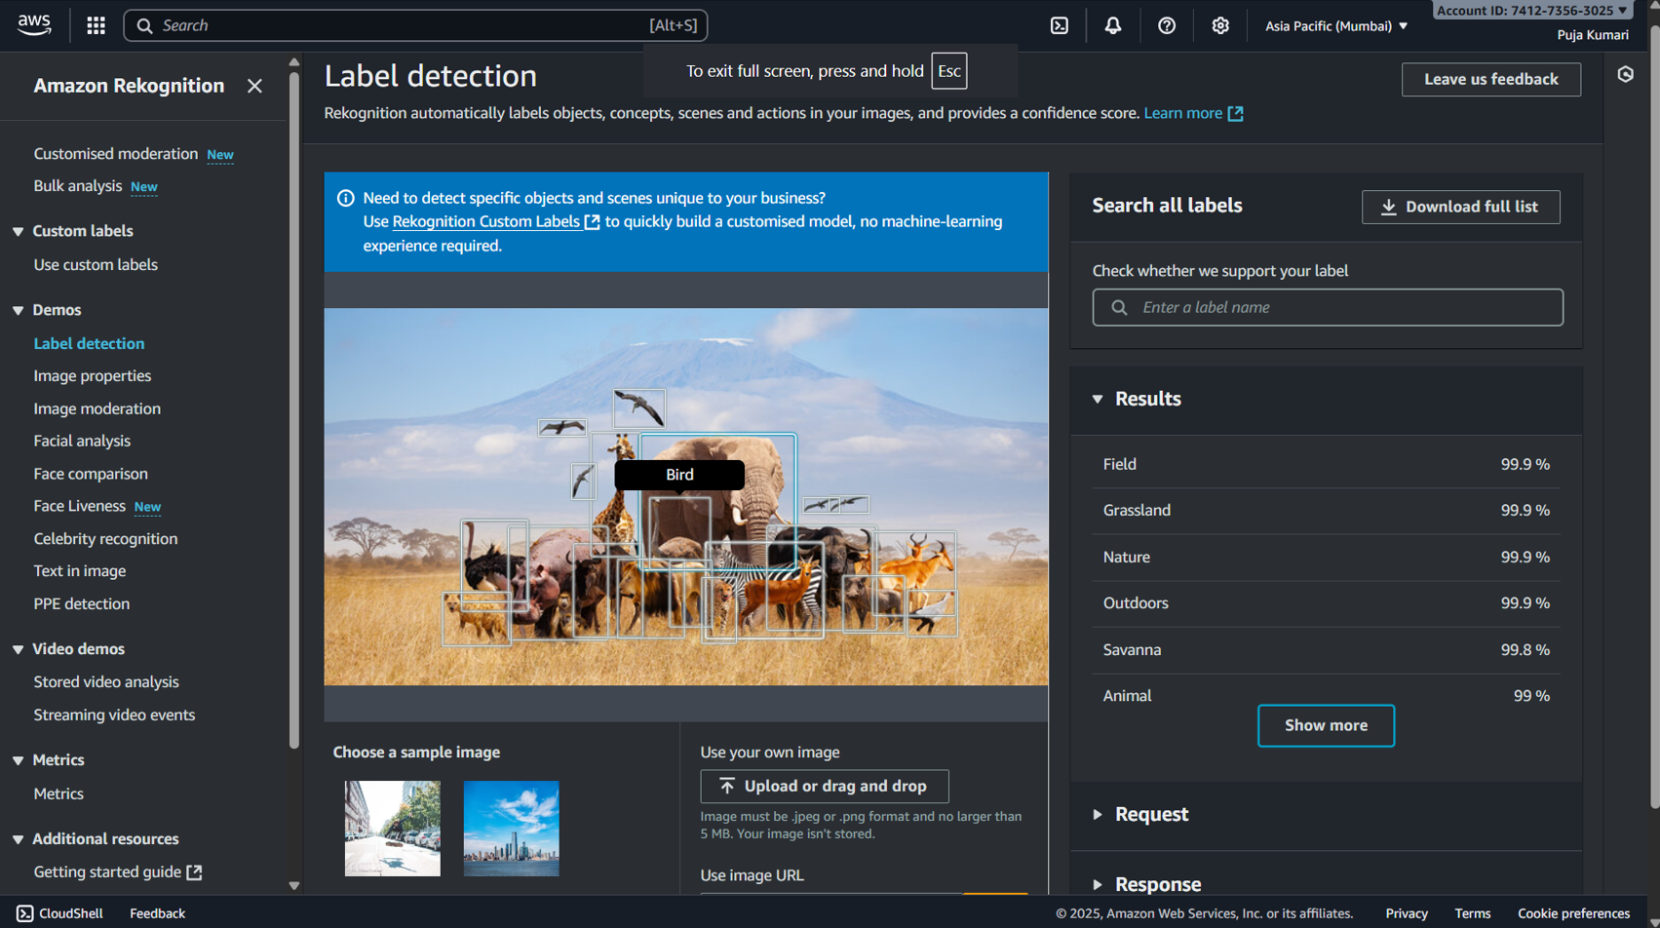
Explaination:-
- Used Amazon Rekognition → Label Detection to analyze an image.
- Rekognition detected animals and objects with bounding boxes.
- Confidence scores for labels (e.g., Field, Nature, Animal) are shown on the right.
Screenshot -2 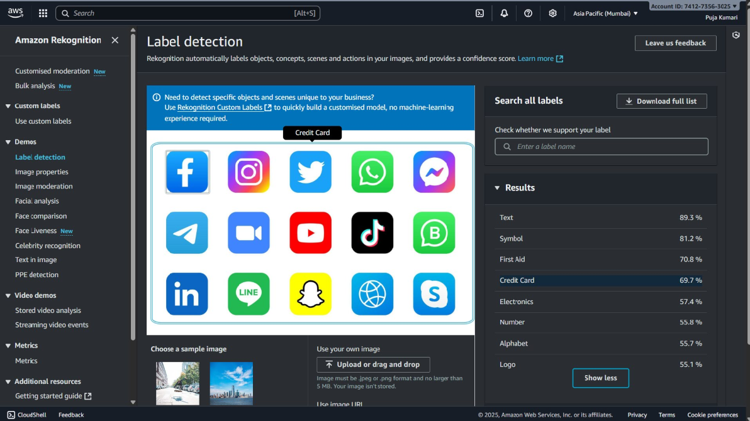
Explaination:-
- Amazon Rekognition → Label Detection to analyze an image containing multiple app icons.
- Rekognition identified labels like Text, Symbol, Credit Card, Electronics, etc., with confidence scores.
- The bounding box highlights one detected label from the image.

